

40th Annual Int’l Rally Richmond, VA September 17-22, 2017
Four Points Sheraton 4700 S. Laburnum Avenue, Richmond, VA 23231

888-627-8644 / 804-226-4300 Ask for HDS rate $94 Breakfast not included
Cut off date is August 15, 2017

CG www.rockahock.com 1428 Outpost Rd, Lanexa VA 23089 804-966-8362

Please fill out rally form or a note, and return with rally fee payable to (Harley Dressers)
& shirt size to: Jan Travis, 55 Arrowhead Lane, Bullock, NC 27507
Rally check-in is on Sunday afternoon/evening, (Rallies run Monday thru Friday)

------------------------------------------------------------------------------------------c u t---------------------------------------------------------------------------------------------

Int’l Rally Fee $60 single/$120 couple children 12-17 $10, non-family guests + $5 dresserstrav@gmail.com

Names________________________________________________________________ Shirt Sizes________________________

# of Rally Bars Wanted _______$4.50 each,

Guest Names_________________________________________________________________Guest Sizes______________________

# Attending_______ non-family guests $5 Additional Total Enclosed _________

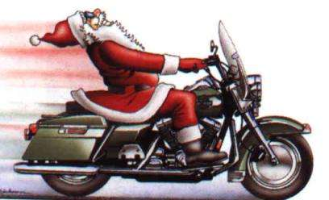
Saturday, November 11, 2017 5:00 PM

HARLEY DRESSERS TOYS FOR TOTS CHRISTMAS PARTY!!

Holiday Inn Harrisburg-Hershey, PA 717-469-0661 Ask for $90 + tax Harley Dressers rate.
604 Station Rd, Grantville, PA 17028 I-81 exit 80
Cut off date is September 10, 2017
Book early! Cancellations accepted 48 hrs before arrival
For info call Jim & Jean Gagnon 440-585-1823

Please fill out Christmas Party form or a note, and return with check to pay dinner fee payable to (Harley Dressers) to: Jan Travis, 55 Arrowhead Lane, Bullock, NC 27507 dresserstrav@gmail.com
------------------------------------------------------------------------------------------c u t---------------------------------------------------------------------------------------------

Names __________________________________________________ cut-off date September 10, 2017

# for Dinner : Adults $35 ________ Children under 4- 12 $17.50 ( Boys ages_____ Girls ages_____
Total ___________

